Questions on videos: “what is Fairtrade?” and « The Fairtrade Story”

- What is Fairtrade?

- How can Fairtrade improve the farmer’s working and living conditions in developing countries?

- Growing is a hard work, explain why does famers earn so little money from this activity?

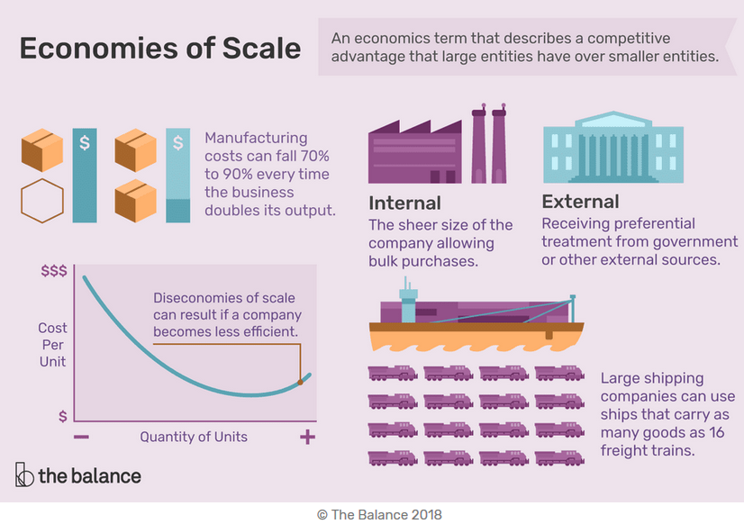
- What does free market/open market mean?

Coffee and Tea distribution channels
Growers
Processors
Traders

Supermarkets coffee shops web shops café, hotels, restaurant Vending machines

Main traders in France on coffee and Tea market

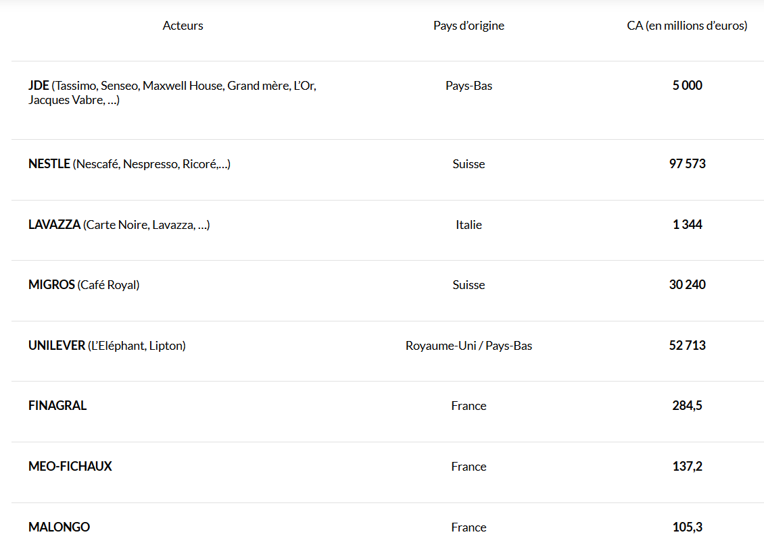
- How can farmers fight to change their condition?

- What is one of the central components of the Fairtrade system?

- Why is this component central?

- In a more global aspect, what does Fairtrade improve?

- Usually, on which criteria our decisions to buy food in a supermarket are based on?

- Finally, how the decisions we make can have a significant impact on farmers?

